**Keys To Selecting Markets That Will Move Explosively**



1. We look for the major 4 asset classes, interest rates markets, stocks, commodities and currencies they are all trying to trend, not conflicting with each other and not in consolidation, we want to see at least 2 of them trending.
2. This is the approach using the other asset classes to confirm the ideas of your trade. For example if we think a bullish dollar will come, then commodities should fail to make higher highs and the lows are being traded trough easily. The opposite would be seen if we want to see bearish dollar.
3. Look back the last 12 months of the net positions of the commercial trades, we look at the lowest low and highest high in that and then we have a range we divide that in half and use that for being bullish or bearish.
4. Open interest.
5. Seasonal tendency.
6. This is a way of gaging when the market gets quiet before a big explosive move
7. Major news headlines. If we see 2 of the 4 major asset classes trending, and were bullish and a news event comes out and it starts jawing that its not strong and bullish and its weak, then we do the opposite and we keep buying and dont listen to the news
8. Market sentiment



Major 4 asset classes. Are they trending or in consolidation, we want to see 2 at least trending. If stocks are in consolidation then commodities should be trending and vice versa.

Interest rates or currencies, 1 of them must be trending

Group them

Stocks and commodities, 1 of them must be trending Interest rates and currencies, 1 of them must be trending

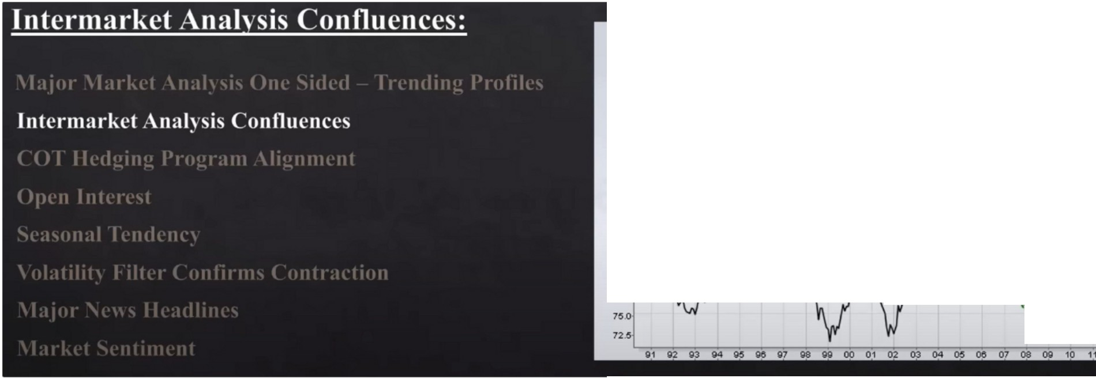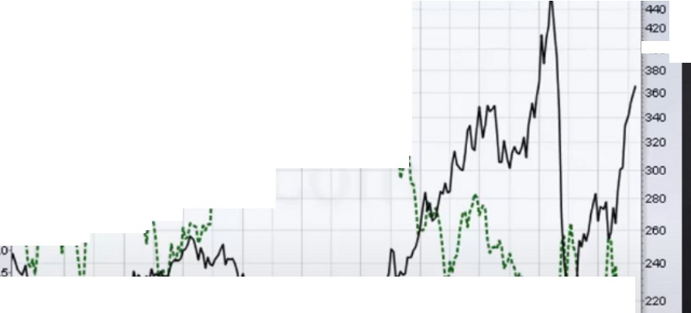

:

:: :

**.o: a, :mttfl.J.66,00**

*J:V*

* !'

400

,.1

""'

::

**:·o**

**" t•"'**

t/'\ *\f t*

\

.:.;\.f\\I¥ \

**f.:.:\**

**S,•, W**

***r*** .

*,:*

82

77

'-T--- \

: **200**

\..'

There was a specific teaching in january about it. lntermarket analysis

Is a bullish idea on 1 asset class supported by another asset class, so if were bullish on the dollar does commodities support the idea by going lower and has it come into resistance?

When the dollar is weak, for commodities many times they take out an old low then you can expect a turtle soup situation on commodities.

Are we seeing commodities taking lows out easy and does it have high resistance on the highs? If it takes out a high thats no problem but does it reject immediately after that?

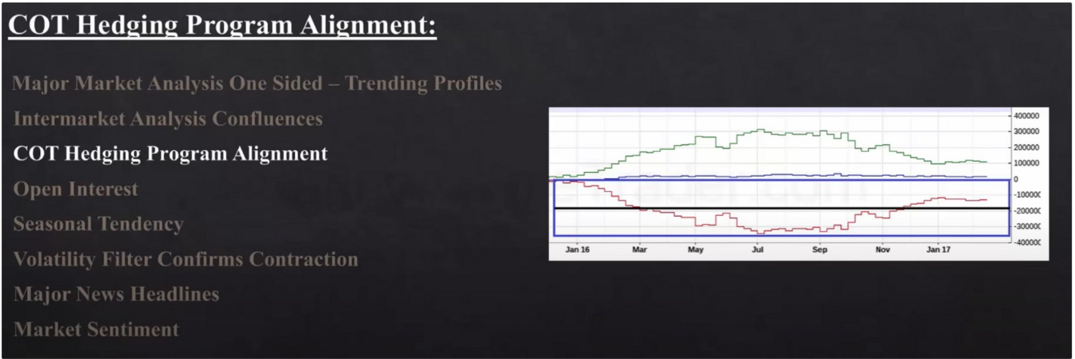

We look at the last 12 months of the commitment of trades report. Because hedging is usually done using the last 12 months for data.

barchart.com commitment of traders report

**400000**

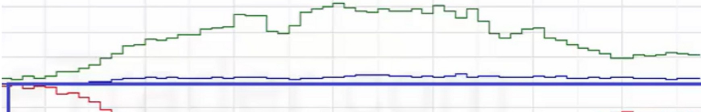**300000**

**200000**

**100000**

**0**

**-lOOOOC**

**1------...;;;;;i--= .....------------- ---= l!-20000C**

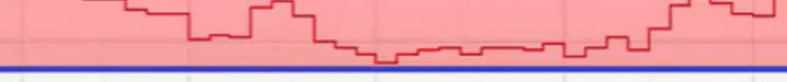

**-30000(**

**-40000(**

ICT frames the last 12 months, and notes the highest high and lowest low and divide it in half and then has a new O line. That new range is his net long or net short position

January 2016 you can see thats where the highest portion of their holdings where, theyre slightly below the O line so theyre either neutral or slightly bearish.

And in july theyre at the lowest point, so thats your range and divide that in half and thats going to be your new O level, or in other words your new bullish or bearish level

You can see in december of 2016 that they went above that new adjusted O line, so they were buying aggressively in december.

If we see this in alignment with trending enviroment and we expect bullish prices and with intermarket analysis then we can go to the next stage which is open interest



**400000**

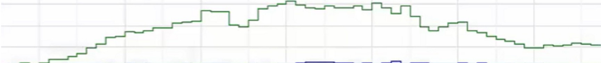**300000**

**200000**

**100000**

**--,.;;;;=...;;....;;.= ;........;;==;;....----------.....;=...;;.;....===;;...---.lo**

**-lOOOOC**

**----...;;;;...., -------------- ---=,...--------ll-2000(X**

**-30000(**

# "----------------....l;;;:.....---------------- 11

**-40000(**

**Jan 16 Jul Sep Nov Jan17**

If were having a bearish market and we see this, then this would not be supportive of a strong sell. So wait for the line to get back below our new O line

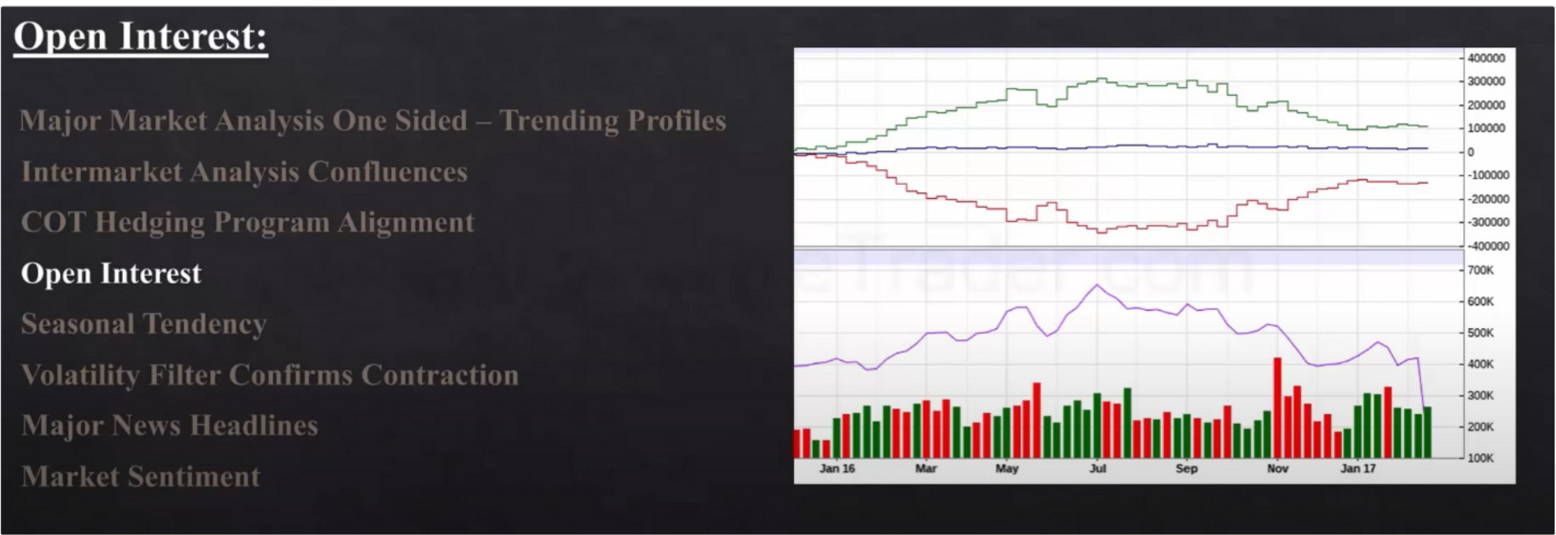

If open interest decline 15% or more thats indication of banks short covering, theyre thinking price will go up otherwise they would hold on to their shorts. Its confirmed when you see the COT go

higher to the 0 line, otherwise the red line would be either staying flat or staying lower. Purple line open interest drops 15%, so COT should go higher to confirm it

If we see open interest rally more than 15% and COT drops that is bearish confirmation

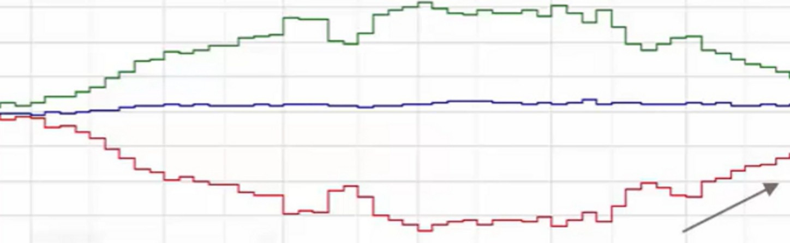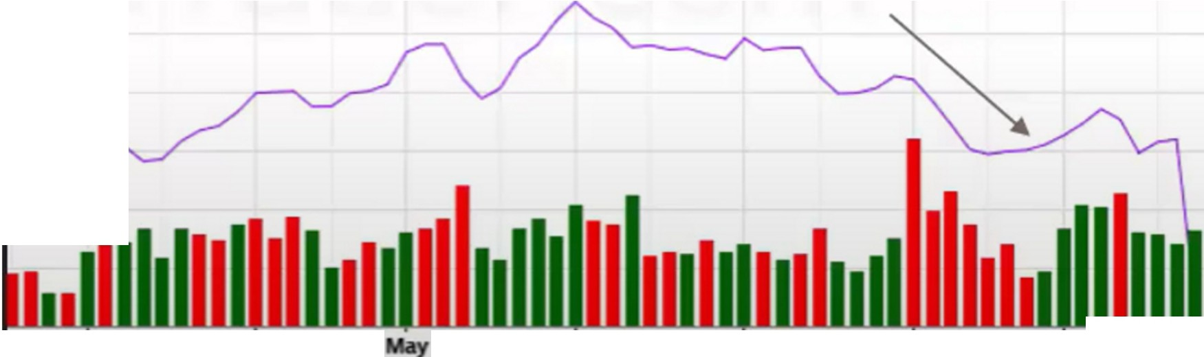

**400000**

**300000**

**200000**

**100000**

**0**

**-100000**

**-200000**

**-300000**

**t======================================!-400000**

**700K**

**600K**

**SOOK**

**400K**

**300K**

**200K**

**Janl6**

**MM**

**Jul**

**Sep**

**Nov**

**-----.J100K**

**Jan 17**

Bullish open interest + COT

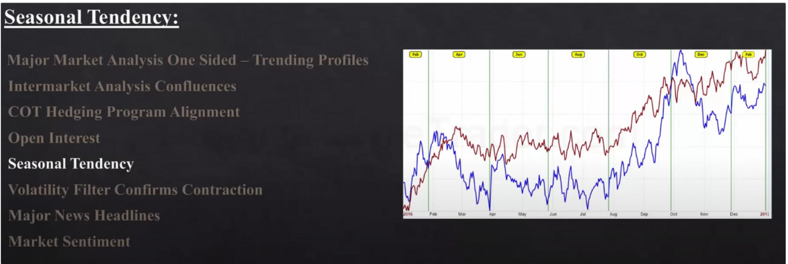

We want to take a trade when seasonal tendencies are aligned

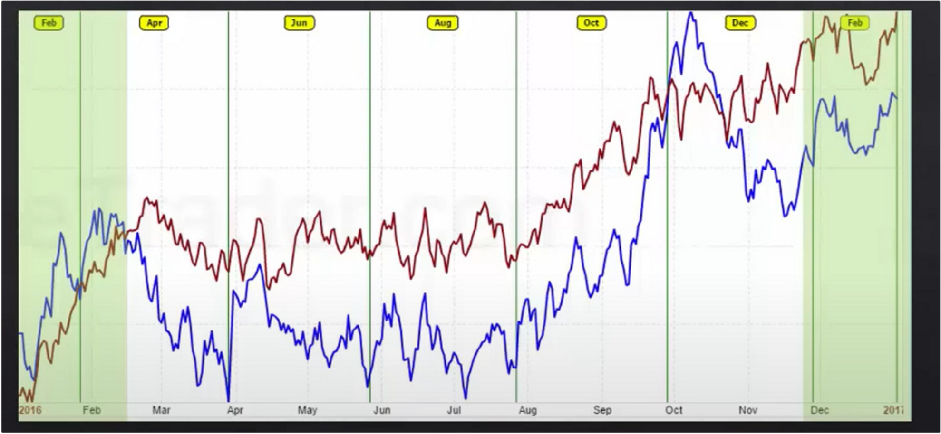

We now have 5 things in our favour suggesting explosive higher prices

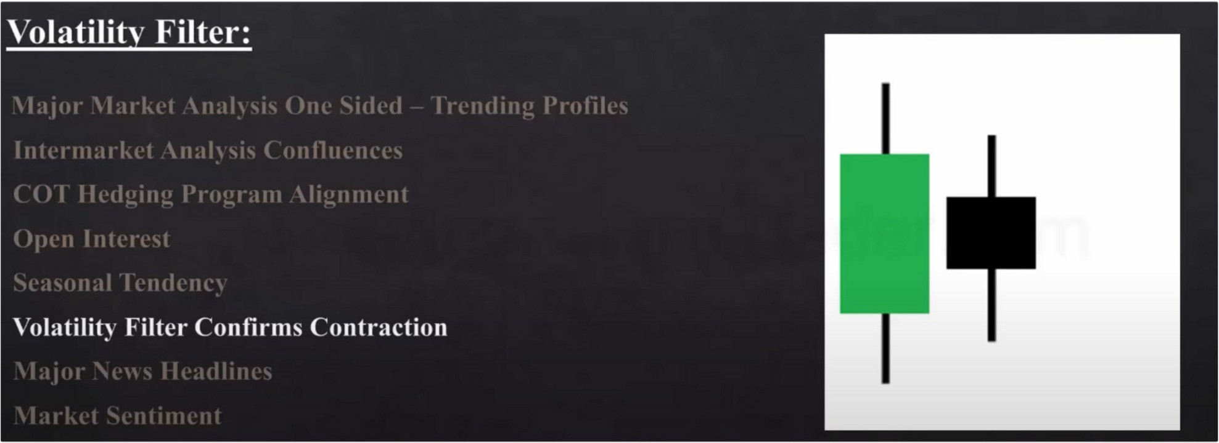

Volatility filter, this can be applied to every timeframe Price moves from large ranges to small ranges

We look at the body of the candle, not the wicks

# Lower High



**Volatility Contraction**

# Higher Low

It creates an inside bar, high probability that the next candle or the candle after that will be a large range candle. Especially if you have a condition thats poised to trade higher or lower.

For example when were at support and we have all the other confluences from above suggesting bullish prices, then the next or the one after should be explosive bullish prices.

It doesnt give you the timing but it gives you the stage that it will likely have an explosive price move to the upside.

You can view this also as the smallest range in the last 7 days, you can also use the last 3 days ICT uses any inside bar. Its like a spring

News headlines

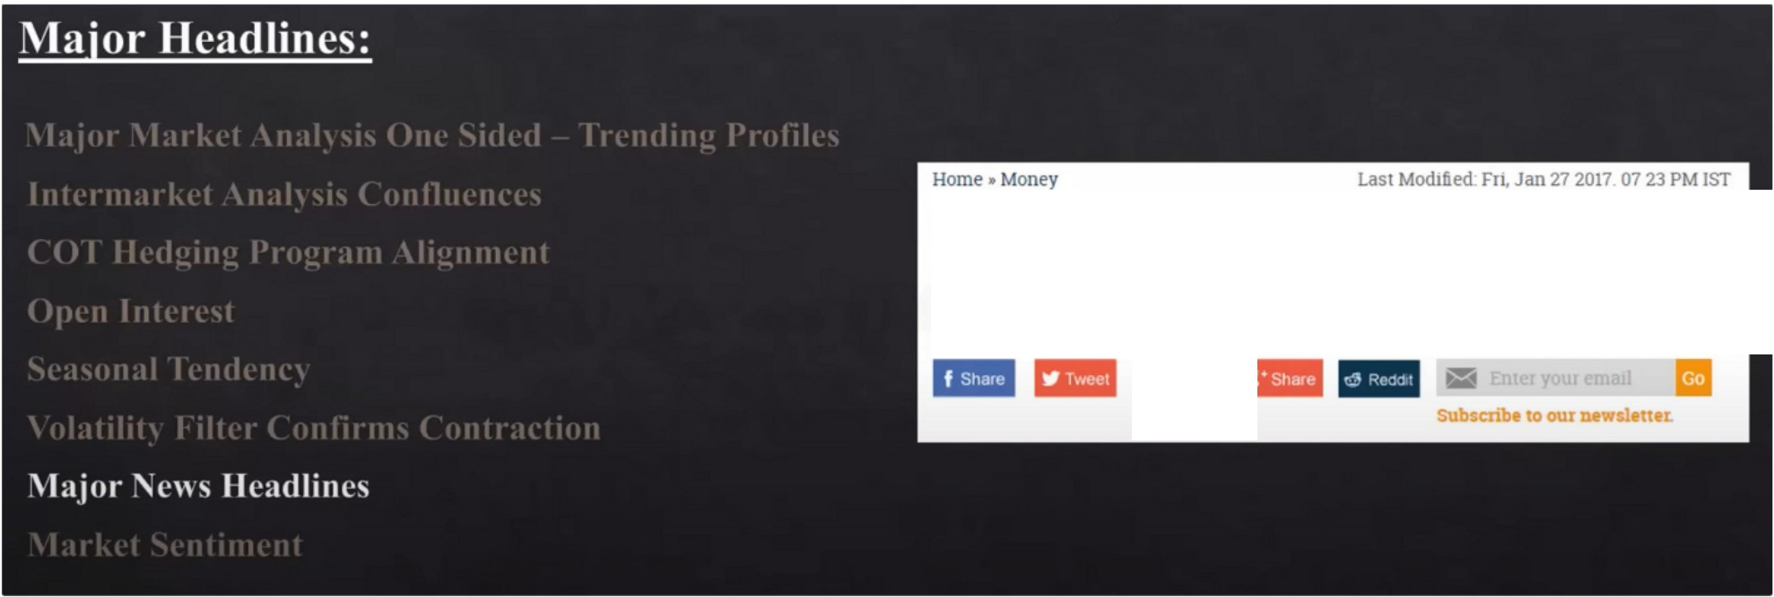

**Gold prices drop to two-week lows on global cues**

Standard gold prices dropped by Rs420 to end at Rs28.705 per 10 gram

**1111** :

If were bullish and everything is supporting it, we like to see headlines that suggest it should go down to trick the market sentiment.

Ideally when were bearish and we come into resistance ideally we want to see bullish news

ICT uses futuresmagazine and does the opposite of them Marketwatch or CNBC, do the opposite of them

Market sentiment

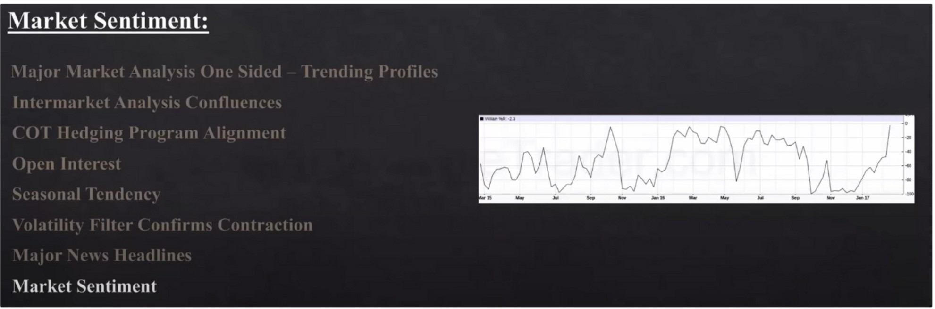

ICT uses an indicator called "william %R"

Its the most accurate for seeing overbought and oversold Plot a 15 period

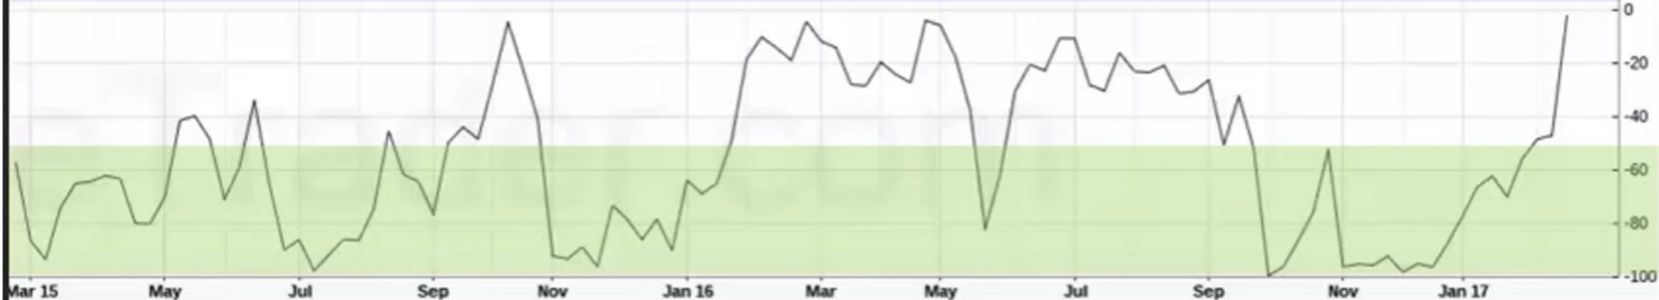

* **VlaillnM"•U**

This is oversold, anything below the -50. So thats a buying area

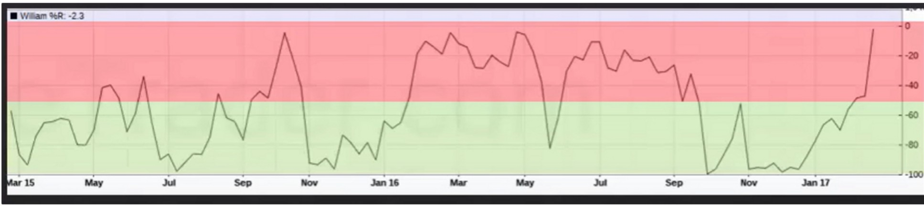

Anything above is overbought, so selling area

If were at the 50 level and left the oversold area we will still factor a potential buy

And if we left a overbought condition and recently traded down and hovered around the 50 level i will favour the overbought side, so we'll look for sells

So whatever area we came from most recently we like to go with that sentiment

Arjo I Twitter, lnstagram I Linktree

Linktree. Make your link do more.

, https://t.co/HhmmTN1fUI

JavaScript is not available.

"# https://twitter.com/arjoio